Computer Networks Lab 1

Name: CAO Xinyang

HDU ID: 20321308

1. Create a topology in figure

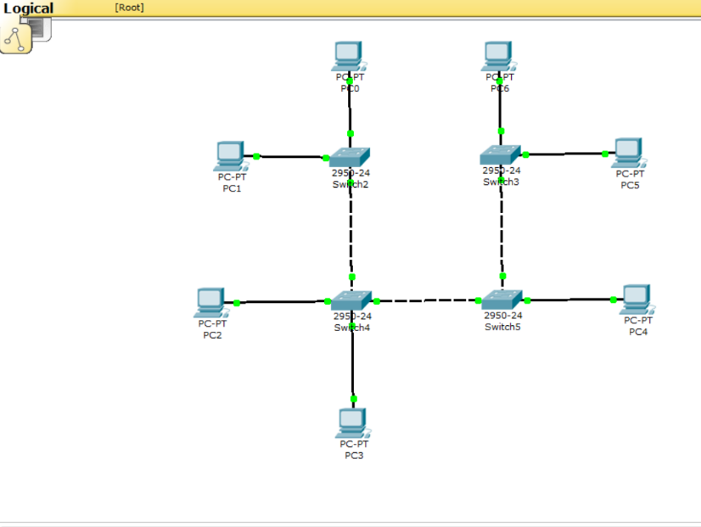

2. Assign addresses to computers, according to option “v”. “v” – is your last digit

of your HDU ID.

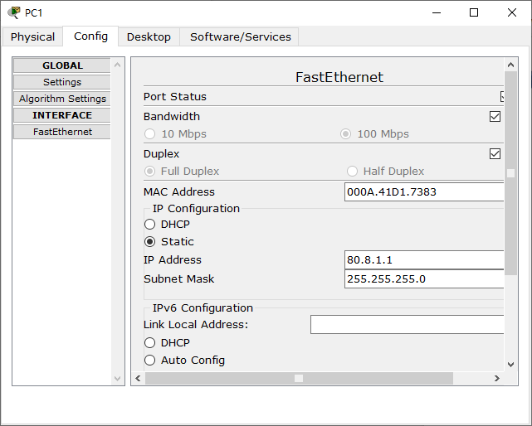 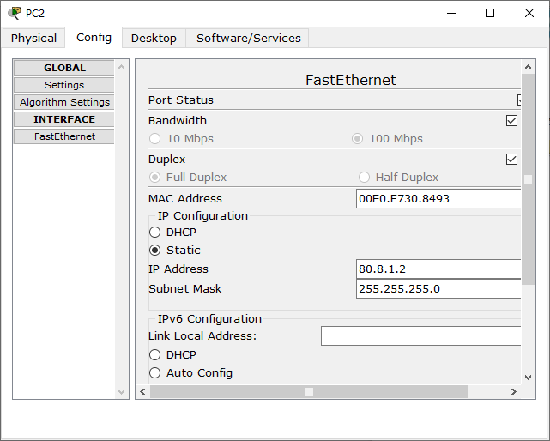 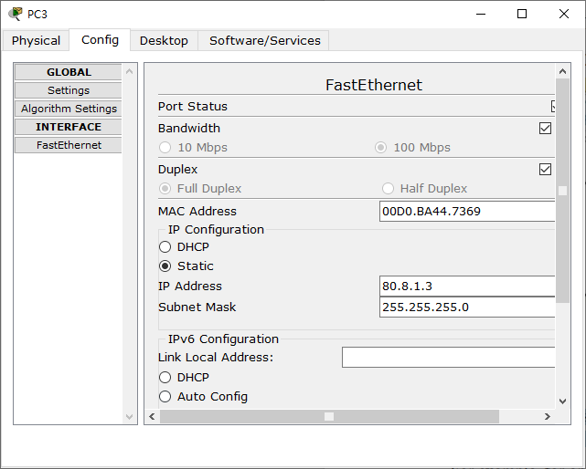

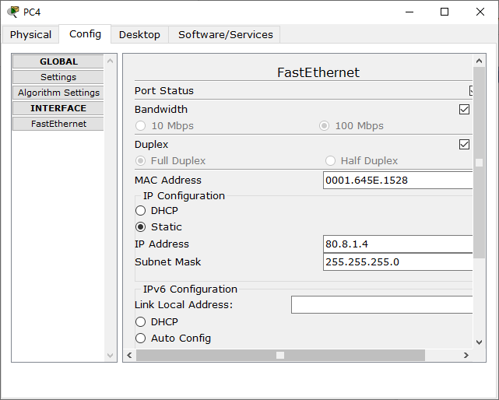 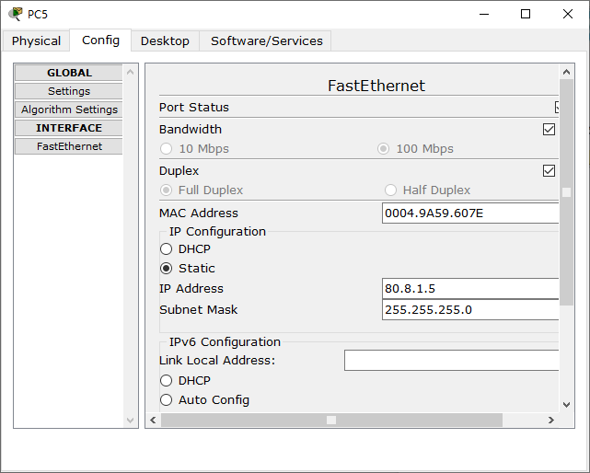 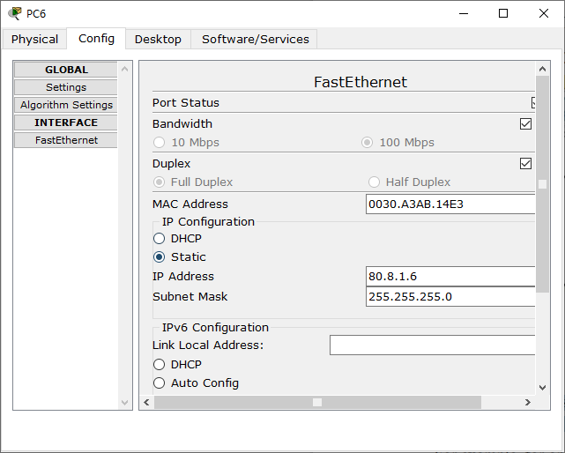

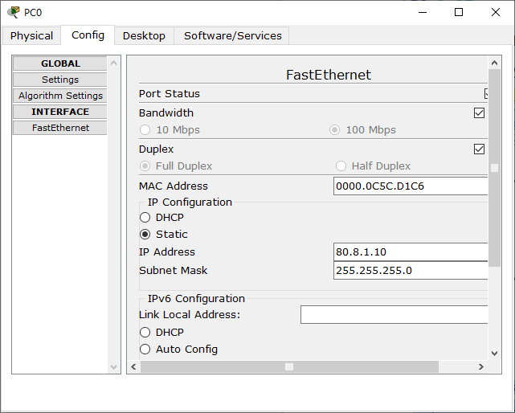

3. Run the ping utility, according to the table.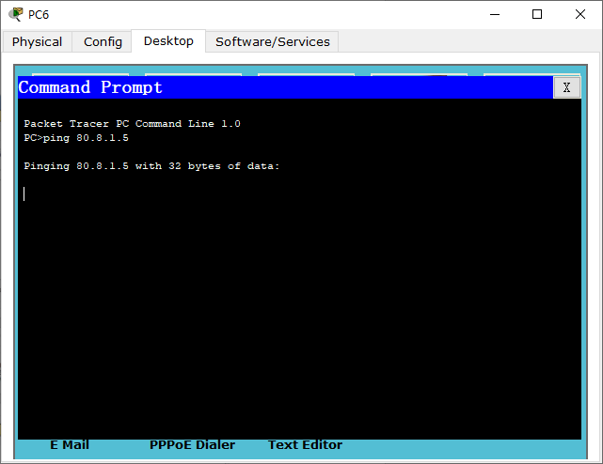

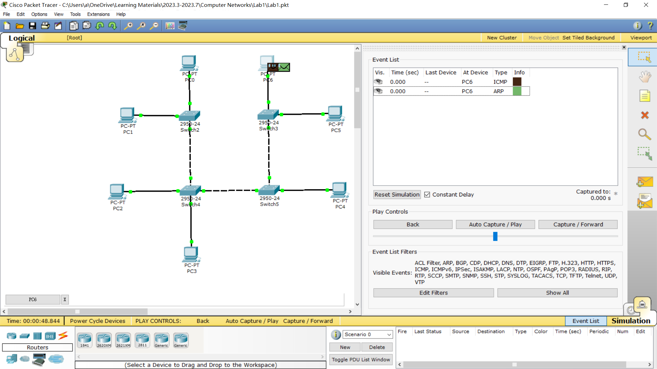

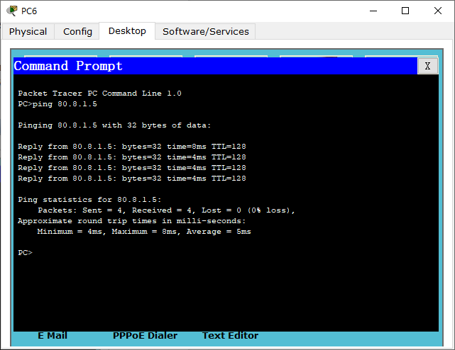

4. In" simulation Mode", track the movement of packets and the protocols used

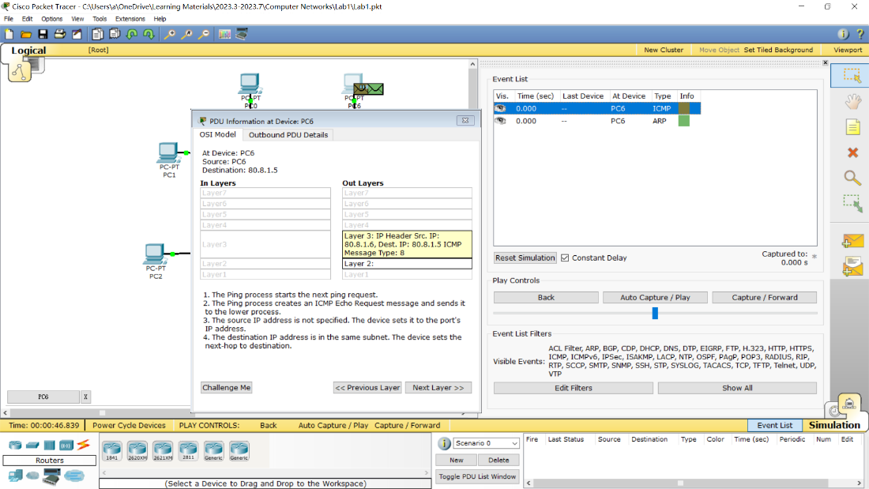

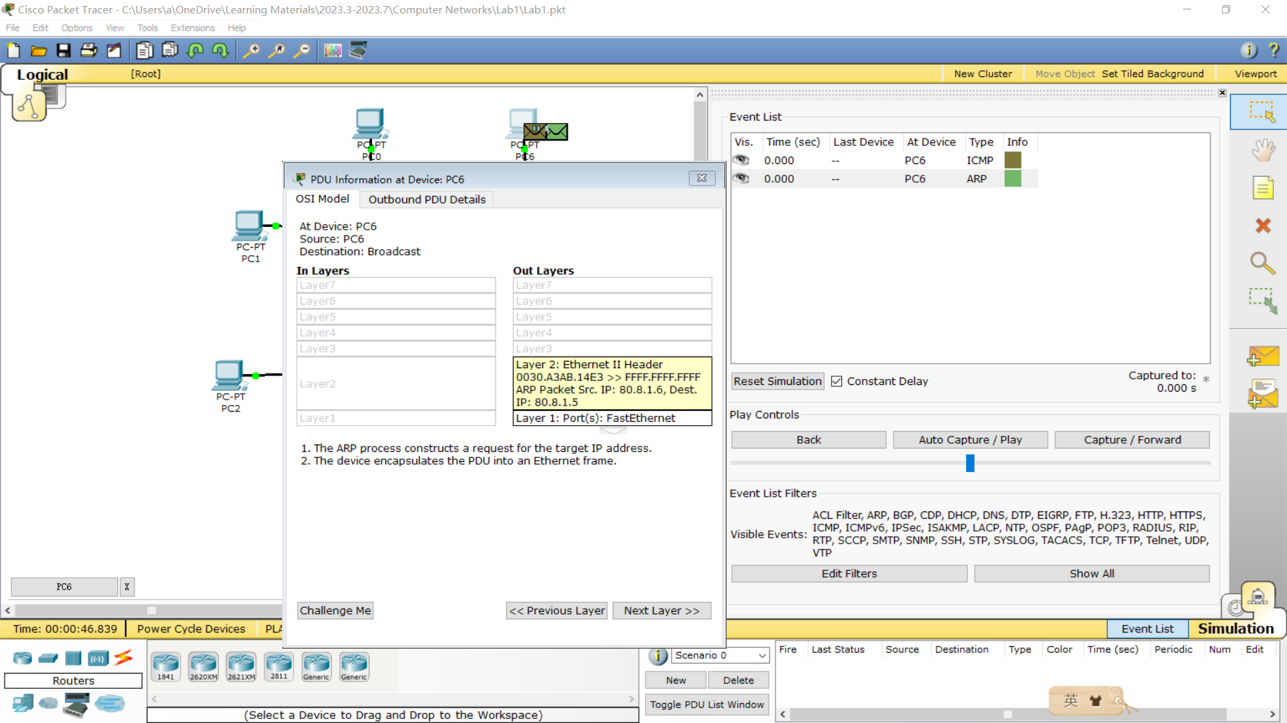

5. Switching to "Simulation Mode" to review and explain the process of data exchange over the ICMP Protocol between devices (by executing the 𝑃𝑖𝑛𝑔 command from one computer to another item. Include a detailed explanation in the report.

Answer:

When a ping command is issued from a source machine(PC6), an echo-request packet is sent to the IP address(80.8.1.5) of the target machine(PC5): This ICMP echo request is generated to confirm whether the target machine is reachable. The target machine responds to the echo-request using an ICMP echo reply.

6. Make sure that all network objects are reachable using the IP Protocol.

***Done.***

Answer on the questions:

1. What is difference between hub and switch?

A hub operates on the Physical layer of the OSI model, while a switch operates on the Data link layer of the OSI model. A hub uses broadcast transmission, meaning that data is sent to all connected devices, while a switch can use unicast, multicast, or broadcast transmission. This means that a switch can send data to specific devices, rather than all connected devices.

Additionally, hubs typically have fewer ports than switches. A hub may have 4 or 12 ports, while a switch can have 24 to 48 ports.

2. What layer of OSI model is used for the switching?

Switching operates on the Data link layer of the OSI model.

3. Describe the aims of subnet mask?

A subnet mask is a 32-bit address that segregates an IP address into network bits that identify the network and host bits that identify the host device operating on that network. The main aim of a subnet mask is to encapsulate a range of IP addresses that a subnet can use, wherein the subnet refers to a smaller network within a more extensive network.

4. Do we have one subnetwork or 4 (because we have 4 switches)? Explain.

One. Because all switches are connected in series, and the devices connected to all switches have the same network address(all of them are 80.8.1.x) and subnet mask(255.255.255.0). In this way, they can communicate within the same subnet. So there is only one subnetwork.

5. What will happen if we will change the address of PC6 to v*10. v.2.6 and make

ping-request from PC1 to PC6? Is it successful or not? Explain, please, why?

No. The IP address of all devices in the subnet is 80.8.1.x. When the IP address of PC6 is changed to 80.8.2.6, PC6 does not belong to the subnet and therefore cannot make

ping-request from PC1 to PC5, but can still make ping-request to PC6(itself).